Application Lab file

Hemant Arya Panwar

11911075

CSE

* Create an HTML web page form

<!DOCTYPE html>

<html lang="en">

<head>

<meta charset="UTF-8">

<meta name="viewport" content="width=device-width, initial-scale=1.0">

<title>WEB PAGE</title>

</head>

<body>

<center><h1>WEB PAGE Form</h1></center>

<form >

Name :<input type="Name" id="Name" > <br>

Email :<input type="Email" id="Email"><br>

D.O.B :<input type="Date" id="DOB"><br>

<input type="Submit" value="Create Account">

</form>

</body>

</html>

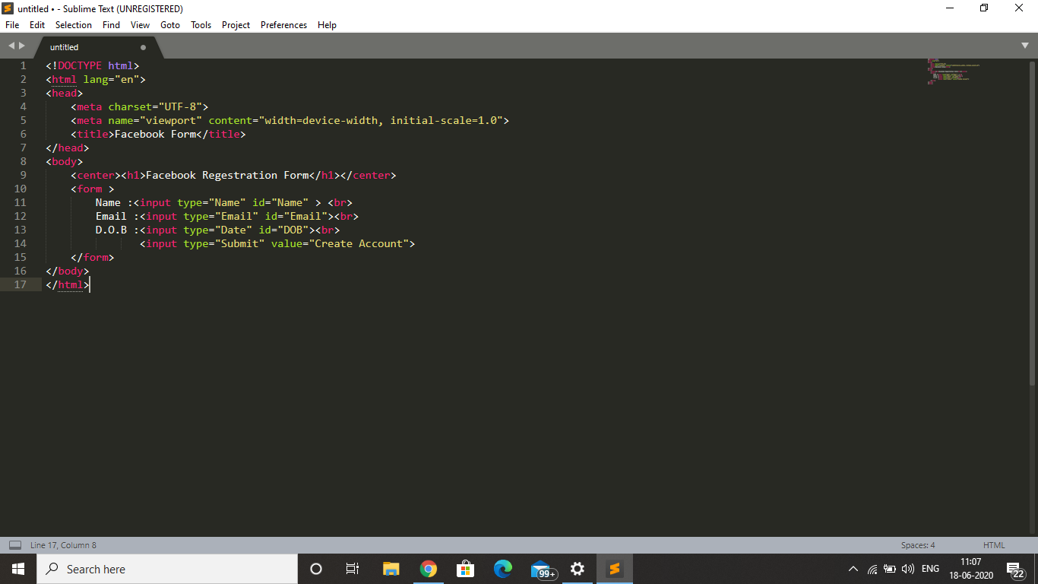

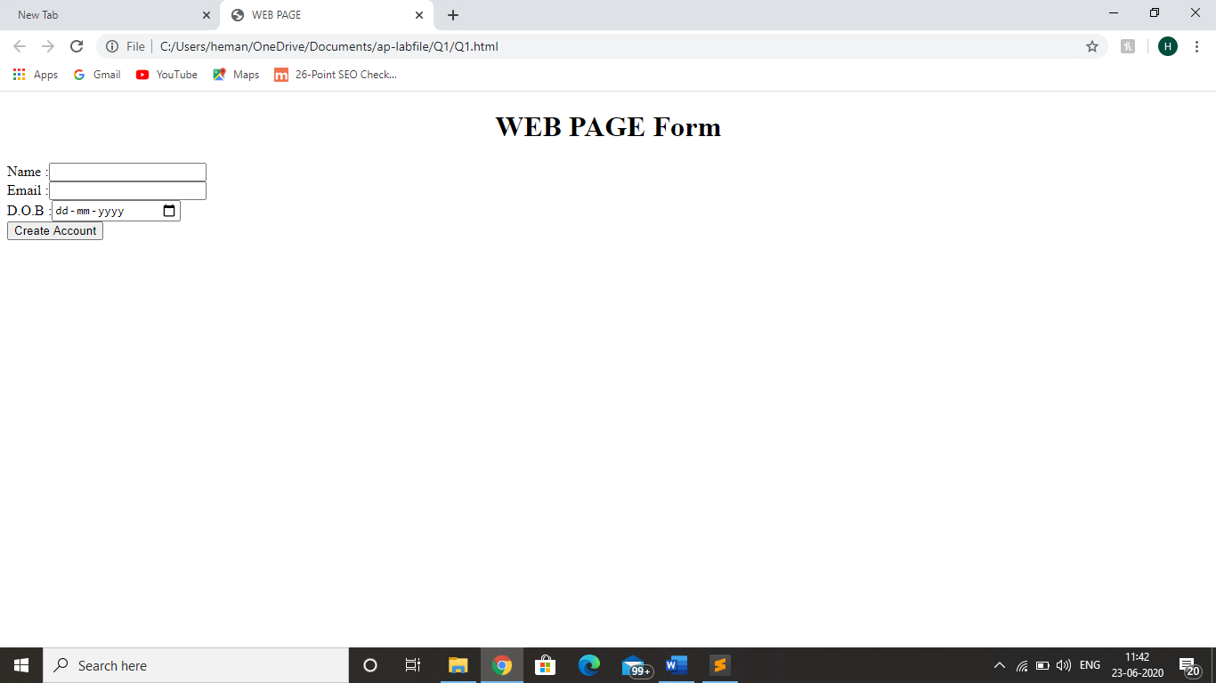

* Create Home page using HTML

HTML code

<html lang="en" dir="ltr">

<head>

<title>Registration Form</title>

<link rel="stylesheet" href="css.css">

</head>

<body>

<div class="ab">

<h1>Create Your Account</h1></div>

<div>

<div class="dv">

<form method="post">

<table width="50%">

<th><label>First Name</label>

<input type="text" placeholder="Enter your Firstname here"></th>

<th><label for="">Last Name</label>

<input type="text" placeholder="Enter your Lastname here"></th>

</table>

<br>

<br>

<div>

<label class="abc"><b>E-mail:</b></label>

<br>

<input type="email" placeholder="Enter your email here">

<br>

<br>

<br>

<br>

<label class="abc"><b>Gender:</b></label>

<input type="radio" name="ab" value="male">Male

<input type="radio" name="ab" value="female">Female

<input type="radio" name="ab" value="others">Others

<br>

<br>

<br>

<br>

<label class="abc"><b>Mobile No:</b></label><br>

<table width="50%">

<th>

<select >

<option>Select</option>

<option>+91</option>

<option>+310</option>

<option>+55</option>

<option>+1</option>

<option>+355</option>

<option>+2</option>

</select></th>

<th>

<input type="text" placeholder="Enter your Mobile number "></th>

</table>

</div>

<hr>

<table width="30%">

<th><input type="submit" value="Register"></th>

<th><input type="reset" value="Clear"></th>

</table>

</form>

</div>

</div>

</body>

</html>

Css code

.dv{ background-color:Lightgrey;

margin: 0px 300px 300px 300px;}

.abc{margin-left: 60px;}

input[type=email]{width:50%;

margin-left: 60px;

}

body{background-color:white}

.ab{text-align: center;

text-shadow: 5px;

padding: 2px;

margin: auto;}

output

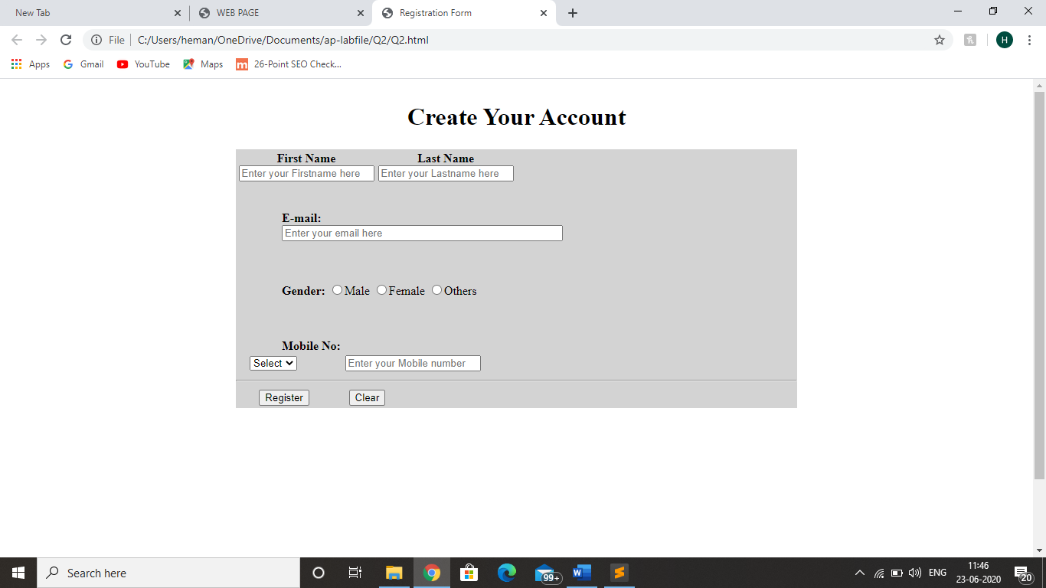

* Create an XHTML and CSS and understanding its use in creating web pages

HTML code

<!DOCTYPE html>

<html>

<head>

<title>LOGIN PAGE</title>

<link rel="stylesheet" type="text/css" href="style.css">

</head>

<body>

<div class="login">

<h1>Login</h1>

<form method="post">

<input type="text" name="u" placeholder="Username" required="required" />

<input type="password" name="p" placeholder="Password" required="required" />

<button type="submit" class="btn btn-primary btn-block btn-large">Let me in.</button>

</form>

</div>

</body>

</html>

CSS code

@import url(https://fonts.googleapis.com/css?family=Open+Sans);

.btn { display: inline-block; *display: inline; *zoom: 1; padding: 4px 10px 4px; margin-bottom: 0; font-size: 13px; line-height: 18px; color: #333333; text-align: center;text-shadow: 0 1px 1px rgba(255, 255, 255, 0.75); vertical-align: middle; background-color: #f5f5f5; background-image: -moz-linear-gradient(top, #ffffff, #e6e6e6); background-image: -ms-linear-gradient(top, #ffffff, #e6e6e6); background-image: -webkit-gradient(linear, 0 0, 0 100%, from(#ffffff), to(#e6e6e6)); background-image: -webkit-linear-gradient(top, #ffffff, #e6e6e6); background-image: -o-linear-gradient(top, #ffffff, #e6e6e6); background-image: linear-gradient(top, #ffffff, #e6e6e6); background-repeat: repeat-x; filter: progid:dximagetransform.microsoft.gradient(startColorstr=#ffffff, endColorstr=#e6e6e6, GradientType=0); border-color: #e6e6e6 #e6e6e6 #e6e6e6; border-color: rgba(0, 0, 0, 0.1) rgba(0, 0, 0, 0.1) rgba(0, 0, 0, 0.25); border: 1px solid #e6e6e6; -webkit-border-radius: 4px; -moz-border-radius: 4px; border-radius: 4px; -webkit-box-shadow: inset 0 1px 0 rgba(255, 255, 255, 0.2), 0 1px 2px rgba(0, 0, 0, 0.05); -moz-box-shadow: inset 0 1px 0 rgba(255, 255, 255, 0.2), 0 1px 2px rgba(0, 0, 0, 0.05); box-shadow: inset 0 1px 0 rgba(255, 255, 255, 0.2), 0 1px 2px rgba(0, 0, 0, 0.05); cursor: pointer; *margin-left: .3em; }

.btn:hover, .btn:active, .btn.active, .btn.disabled, .btn[disabled] { background-color: #e6e6e6; }

.btn-large { padding: 9px 14px; font-size: 15px; line-height: normal; -webkit-border-radius: 5px; -moz-border-radius: 5px; border-radius: 5px; }

.btn:hover { color: #333333; text-decoration: none; background-color: #e6e6e6; background-position: 0 -15px; -webkit-transition: background-position 0.1s linear; -moz-transition: background-position 0.1s linear; -ms-transition: background-position 0.1s linear; -o-transition: background-position 0.1s linear; transition: background-position 0.1s linear; }

.btn-primary, .btn-primary:hover { text-shadow: 0 -1px 0 rgba(0, 0, 0, 0.25); color: #ffffff; }

.btn-primary.active { color: rgba(255, 255, 255, 0.75); }

.btn-primary { background-color: #4a77d4; background-image: -moz-linear-gradient(top, #6eb6de, #4a77d4); background-image: -ms-linear-gradient(top, #6eb6de, #4a77d4); background-image: -webkit-gradient(linear, 0 0, 0 100%, from(#6eb6de), to(#4a77d4)); background-image: -webkit-linear-gradient(top, #6eb6de, #4a77d4); background-image: -o-linear-gradient(top, #6eb6de, #4a77d4); background-image: linear-gradient(top, #6eb6de, #4a77d4); background-repeat: repeat-x; filter: progid:dximagetransform.microsoft.gradient(startColorstr=#6eb6de, endColorstr=#4a77d4, GradientType=0); border: 1px solid #3762bc; text-shadow: 1px 1px 1px rgba(0,0,0,0.4); box-shadow: inset 0 1px 0 rgba(255, 255, 255, 0.2), 0 1px 2px rgba(0, 0, 0, 0.5); }

.btn-primary:hover, .btn-primary:active, .btn-primary.active, .btn-primary.disabled, .btn-primary[disabled] { filter: none; background-color: #4a77d4; }

.btn-block { width: 100%; display:block; }

* { -webkit-box-sizing:border-box; -moz-box-sizing:border-box; -ms-box-sizing:border-box; -o-box-sizing:border-box; box-sizing:border-box; }

html { width: 100%; height:100%; overflow:hidden; }

body {

width: 100%;

height:100%;

font-family: 'Open Sans', sans-serif;

background: #092756;

background: -moz-radial-gradient(0% 100%, ellipse cover, rgba(104,128,138,.4) 10%,rgba(138,114,76,0) 40%),-moz-linear-gradient(top, rgba(57,173,219,.25) 0%, rgba(42,60,87,.4) 100%), -moz-linear-gradient(-45deg, #670d10 0%, #092756 100%);

background: -webkit-radial-gradient(0% 100%, ellipse cover, rgba(104,128,138,.4) 10%,rgba(138,114,76,0) 40%), -webkit-linear-gradient(top, rgba(57,173,219,.25) 0%,rgba(42,60,87,.4) 100%), -webkit-linear-gradient(-45deg, #670d10 0%,#092756 100%);

background: -o-radial-gradient(0% 100%, ellipse cover, rgba(104,128,138,.4) 10%,rgba(138,114,76,0) 40%), -o-linear-gradient(top, rgba(57,173,219,.25) 0%,rgba(42,60,87,.4) 100%), -o-linear-gradient(-45deg, #670d10 0%,#092756 100%);

background: -ms-radial-gradient(0% 100%, ellipse cover, rgba(104,128,138,.4) 10%,rgba(138,114,76,0) 40%), -ms-linear-gradient(top, rgba(57,173,219,.25) 0%,rgba(42,60,87,.4) 100%), -ms-linear-gradient(-45deg, #670d10 0%,#092756 100%);

background: -webkit-radial-gradient(0% 100%, ellipse cover, rgba(104,128,138,.4) 10%,rgba(138,114,76,0) 40%), linear-gradient(to bottom, rgba(57,173,219,.25) 0%,rgba(42,60,87,.4) 100%), linear-gradient(135deg, #670d10 0%,#092756 100%);

filter: progid:DXImageTransform.Microsoft.gradient( startColorstr='#3E1D6D', endColorstr='#092756',GradientType=1 );

}

.login {

position: absolute;

top: 50%;

left: 50%;

margin: -150px 0 0 -150px;

width:300px;

height:300px;

}

.login h1 { color: #fff; text-shadow: 0 0 10px rgba(0,0,0,0.3); letter-spacing:1px; text-align:center; }

input {

width: 100%;

margin-bottom: 10px;

background: rgba(0,0,0,0.3);

border: none;

outline: none;

padding: 10px;

font-size: 13px;

color: #fff;

text-shadow: 1px 1px 1px rgba(0,0,0,0.3);

border: 1px solid rgba(0,0,0,0.3);

border-radius: 4px;

box-shadow: inset 0 -5px 45px rgba(100,100,100,0.2), 0 1px 1px rgba(255,255,255,0.2);

-webkit-transition: box-shadow .5s ease;

-moz-transition: box-shadow .5s ease;

-o-transition: box-shadow .5s ease;

-ms-transition: box-shadow .5s ease;

transition: box-shadow .5s ease;

}

input:focus { box-shadow: inset 0 -5px 45px rgba(100,100,100,0.4), 0 1px 1px rgba(255,255,255,0.2); }

OUTPUT

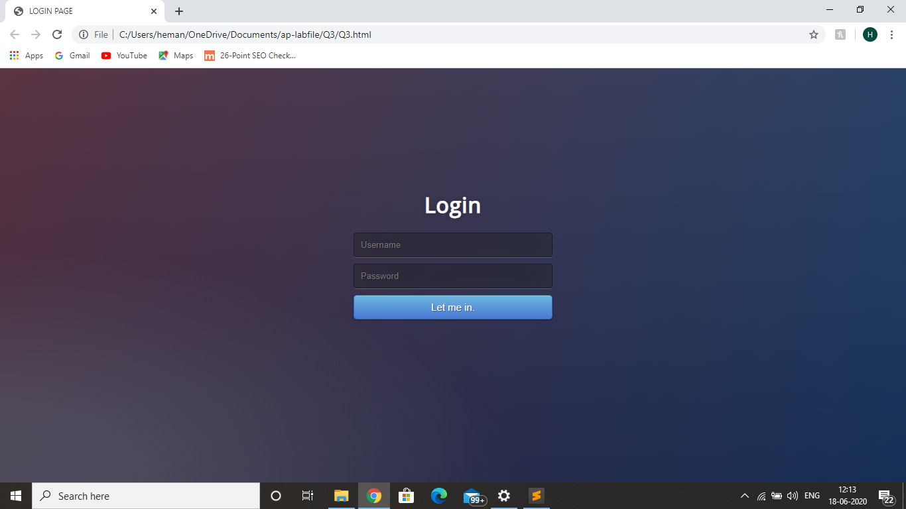

* Setting up and configuration of Apache tom cat server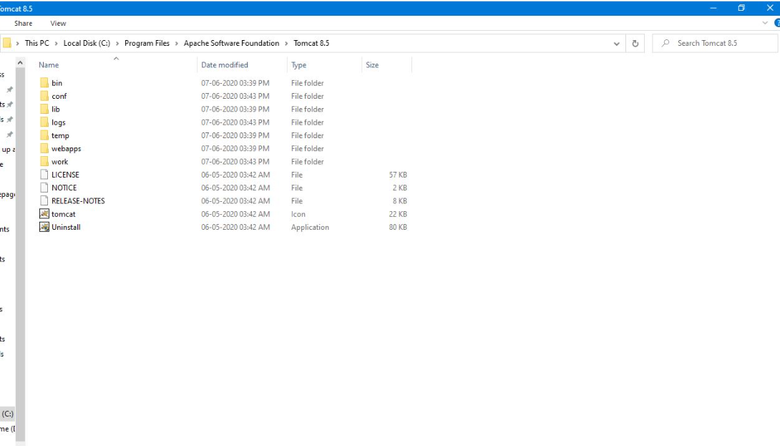



* Create Website using PHP

HTML code

<!DOCTYPE html>

<html>

<head>

<title>

project 1

</title>

<link rel="icon" type="image/x-icon" href="C:\Users\HP\Downloads\icon.png">

</head>

<body bgcolor="#eee">

<style>

*{

font-style: italic;

font-family: cursive;

}

form{

/* border: 1px solid black; */

padding: 20px;

width: 70%;

text-align: left;

/* border-top: 5px solid blue; */

}

label{

background-color: #ccc;

}

.n{

background-color: #eee;

}

</style>

<center>

<br><br>

<!-- <div style=" width: 70%; background-color: aqua; text-align: center;">Photo-details</div> -->

<form name="photo" id="photo" method="POST" action="http://localhost/test.php">

<fieldset>

<legend style="width: fit-content; background-color: aqua;">

Photo-details</legend>

<label for="title">Title</label><br>

<input type="text" name="title" size="80" class="required"><br><br>

<label for="des">Description </label><br>

<textarea name="des" rows="5" cols="90" maxlength="100" class="required"></textarea><br><br>

<label for="cont">Continent</label><br>

<select name="cont">

<option value="asia">Asia</option>

<option value="eur">Europe</option>

<option value="NA">North America</option>

<option value="SA">South America</option>

<option value="africa">Africa</option>

<option value="aus">Austrailia</option>

</select><div style="width: 30%; border: 1px solid #777; float: right;">

<label for="copyright">Copyright?</label><br>

<input type="radio" name="copyright" value="arr">

<label for="arr" class="n">All rights reserved</label><br>

<input type="radio" name="copyright" value="cc">

<label for="cc" class="n">Creative Commons</label>

</div><br>

<label for="con">Country</label><br>

<select name="con">

<option value="ind">India</option>

<option value="fra">France</option>

<option value="usa">USA</option>

<option value="chile">Chile</option>

<option value="kenya">Kenya</option>

<option value="nz">New Zealand</option>

</select><br>

<label for="city">City</label><br>

<input type="text" name="city" >

<div style="width: 30%; border: 1px solid #777; float: right;">

<label for="cc type">Creative Commons Types</label><br>

<input type="checkbox" name="cc type" value="atr">

<label for="atr" class="n">Attribution</label><br>

<input type="checkbox" name="cc type" value="nc">

<label for="nc" class="n">Non Commercial</label><br>

<input type="checkbox" name="cc type" value="ndw">

<label for="ndw" class="n">No derivative works</label><br>

<input type="checkbox" name="cc type" value="share">

<label for="share" class="n">Share alike</label>

</div><br><br><br><br><br><br>

<div style="background-color: cyan;">I accept the software license

<input type="checkbox" name="sof-li" class="required">

</div><br>

<label for="no">Rate this photo:</label><br>

<input type="number" min="1" max="5" name="no">

<div style="width: 30%; border: 1px solid #777; float: right;">

<label for="date">Date taken:</label><br>

<input type="date" name="date" ><br><br>

<label for="time">Time taken</label><br>

<input type="time" name="time" >

</div><br>

<label for="color">Color collection:</label><br>

<input type="color" name="color"><br><br><br><br>

<div style="background-color: aqua; text-align: center;">

<input type="submit">

<input type="reset" value="clear">

</div>

</fieldset>

</form>

</center>

<script src="project.js"></script>

</body>

</html>

JAVA code

function isBlank(inputField){

if(inputField.type==="checkbox"){

if(inputField.checked)

return false;

return true;

}

if (inputField.value===""){

return true;

}

return false;

}

function makeRed(inputDiv){

inputDiv.style.backgroundColor="#AA0000";

inputDiv.parentNode.style.backgroundColor="#AA0000";

inputDiv.parentNode.style.color="#FFFFFF";

}

function makeClean(inputDiv){

inputDiv.parentNode.style.backgroundColor="#FFFFFF";

inputDiv.parentNode.style.color="#000000";

}

window.onload = function(){

var mainForm = document.getElementById("photo");

var requiredInputs = document.querySelectorAll(".required");

for (var i=0; i < requiredInputs.length; i++){

requiredInputs[i].onfocus = function(){

this.style.backgroundColor = "#EEEE00";

}

}

mainForm.onsubmit = function(e){

var requiredInputs = document.querySelectorAll(".required");

for (var i=0; i < requiredInputs.length; i++){

if( isBlank(requiredInputs[i]) ){

e.preventDefault();

makeRed(requiredInputs[i]);

}

else{

makeClean(requiredInputs[i]);

}

}

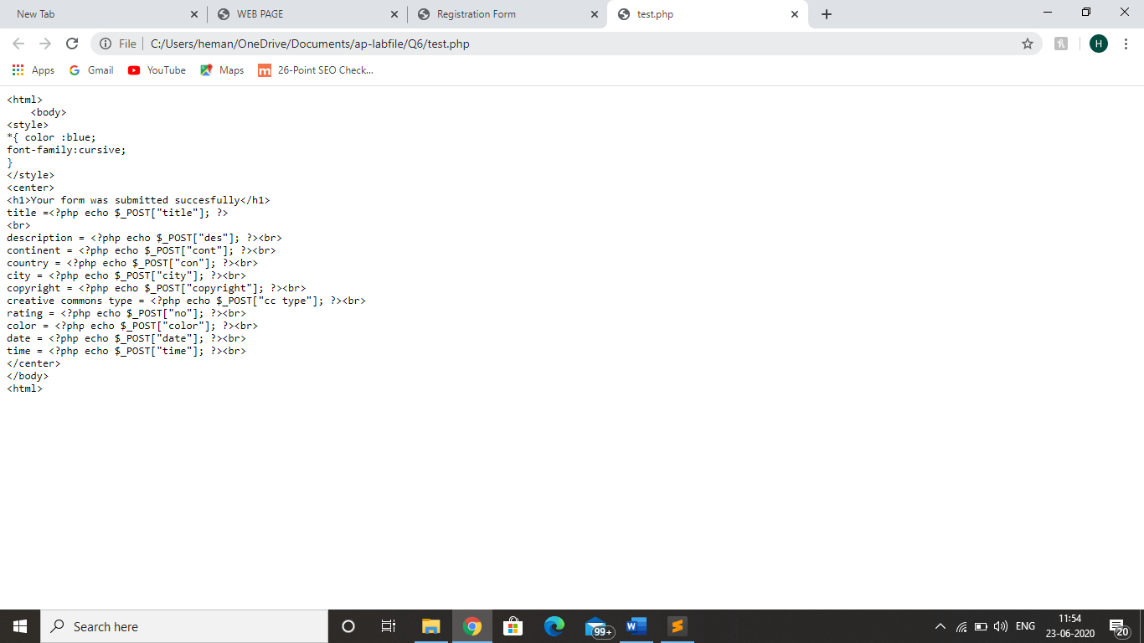

* Creating a web page with ……………… server

<!DOCTYPE html>

<html>

<head>

<title>Hello</title>

<script>

function Divisibleby5()

{

var no = document.querySelector('.num').value;

if(no%5==0)

{

document.write('<h1 align = "center" color="green">Number is Divisible by 5</h1>');

}

else

{

document.write('<h1 align = "center">Number is not Divisible by 5</h1>');

}

}

</script>

</head>

<body bgcolor="orange">

<h3>Divisible by 5</h3>

<form>

<label for="no">Enter Number: </label>

<input type="number" id="no" name="no" class="num" placeholder="5"><br><br>

<input type="submit" value="submit" onclick="Divisibleby5()">

</form>

</body>

</html>

* Writing and understanding program in python

# Program to add two numbers

a=int(input("Enter first number"))

b=int(input("Enter second number"))

sum=a + b

print(f”sum”)

* Using python libraries………………………computations

import math

wish=int(input("Enter 1-logarithmic function \n 2-absolute function \n 3-power function \n 4-trignometric function \n 5-inverse trignometric function"))

if(wish==1):

b=float(input("Enter the base b"))

a=float(input("Enter the number to be taken log to the base {0}".format(b)))

c=math.log(a,b)

print(f"{a} log to the base {b} is {c}")

elif(wish==2):

a=float(input("Enter the number"))

c=math.fabs(a)

print(f"absolute {a} is {c}")

elif(wish==3):

x=float(input("Enter x in x^y"))

y=float(input("Enter the power of {0}".format(x)))

c=math.pow(x,y)

print(f"{x} to the power {y} is {c}")

elif(wish==4):

a=float(input("Enter the angle in degree"))

b=math.sin(a*math.pi/180)

c=math.cos(a*math.pi/180)

d=math.tan(a*math.pi/180)

print(f"sin({a}) = {b}")

print(f"cos({a}) = {c}")

print(f"tan({a}) = {d}")

